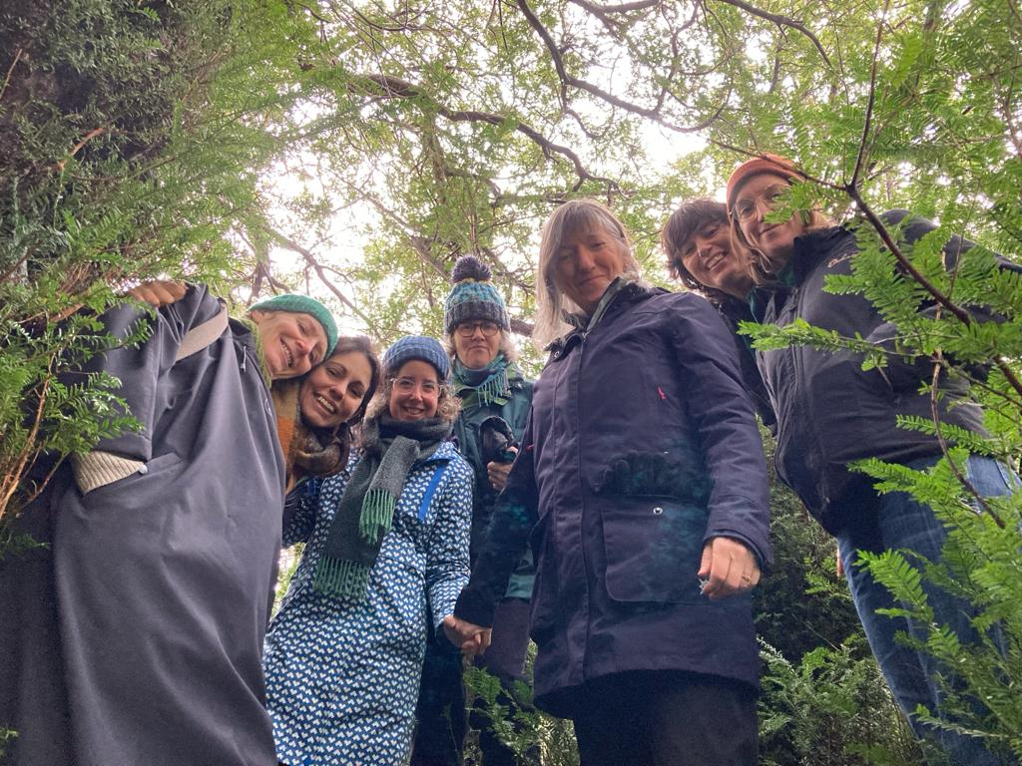
An exciting opportunity has come up to join the support team at Tiratanaloka.

We’re looking for a dynamic mitra who’s asked for ordination or a Dharmacharini to live and work with us full-time.

Could this be you?

Your main responsibility would be to oversee the upkeep of house and grounds.

This will include general upkeep and simple maintenance (as well as liaising with tradespeople, retreatants, volunteers as needed in these areas) and also looking after the needs of the kitchen (e.g. food ordering, retreat recipes, dietary needs and quality control). Training will be provided and you would be part of our lovely support team as well as the broader Tiratanaloka community.

You’d also be involved in Tiratanaloka Unlimited, helping us get ready to move to our new premises!

A full support package is available for the successful candidate.

Some of the skills and qualities you’ll need:
- have an interest in household and general maintenance including kitchen management
• be organised, and able to manage various projects simultaneously
- able to work calmly when under pressure, and work to deadlines
• have good communication skills, both written and verbal, in order to liaise skilfully with retreatants and contractors
• be able both to work independently, as well as being flexible and willing to contribute fully towards collective team tasks
• have a commitment to community living
• have a desire to contribute to the vision of Tiratanaloka

For more information, or to apply, please contact Karunadhi (karunadhi@yahoo.co.uk) or Santavajri (santavajri@gmail.com) by 15th March 2024.

We look forward to hearing from you!

